Hola a toda la clase:  Este material es para leer, entender y pronunciar.  Si tienen dudas, me escriben.  Saludos,  Prof. Gabriela H. | Hi there!  This material is to read, understand and repeat.  If you have any doubts, please email me.  Hugs,  Prof. Gabriela H.
Vocabulary. After reading about Skyfall, read this list of words:
English | Spanish
Film review | Reseña, crítica cinematográfica.
Released | estrenado
Type of film/movie = movie genre | Tipo de película = género
Director
Cast: actor, actress | Reparto: actor, actriz
star (verb) = act | Actuar
in the role of | en el rol de
The plot involves | El argumento se refiere a
exciting action scenes | escenas de acción atrapantes
The film is set | La película se ubica
The soundtrack | La banda de sonido
The theme song | La canción principal
performed by | cantada por
brings his character to life | le da vida a su personaje
a dazzling and memorable performance | una deslumbrante e inolvidable actuación.
Type of movie = genre | El gnero de la película

You can listen to the pronunciation in English in wordreference.com

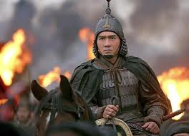
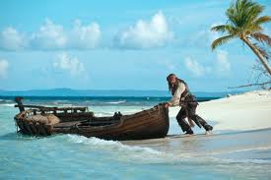
From islcollective.com
1 Adventure film.
Types of films/movies = Genre
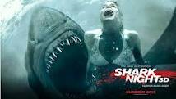
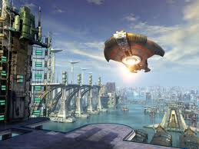
Action film
Animated film
Disaster film
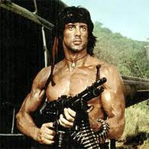
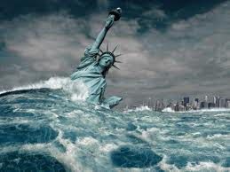
Science fiction film
Historical drama
Horror film
Musical
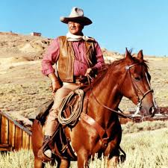
Romantic comedy
War film
Thriller
Western
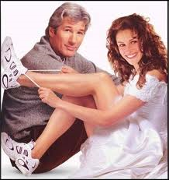
Adventure film
Crime/gangster film
Silent film
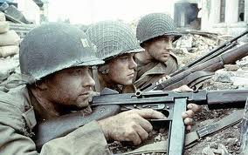
Comedy

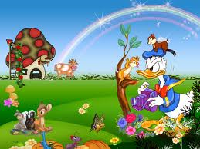
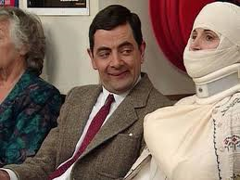
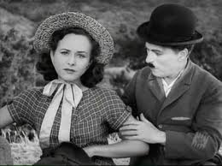
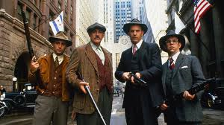
Adjectives to describe movies:
Boring  horrible | Entertaining  Clever  Funny  Gripping  Moving  Exciting  Surprising  Thrilling  Gorgeous  Heart-breaking  Mind-blowing  Beautiful  Award-winning | tragic  frightening  scary  violent

Talking about movies
- What types of movies do you like?/What’s your favorite movie genre?
- Who is your favorite director?
- An your favorite actor or actress?
- What’s the worst movie you have ever seen?
- What makes a film good or bad? The director? The cast? The plot?
- Would you highly recommend a movie?

Thanks for your participation!
We’ll continue with this topic.
Prof. Gabriela H.

