Datos:
Profesora Alicia Velàzquez Inglès
Grupos : 5to C1, 5toc2, 5to C3, 5to B1, 5to B2, 5toB3, 5toB4, 5toB5, 5To B6
Direcciòn de mail para enviar : alivelgam@hotmail.com

Hola, queridos muchachos. Esperando que uds y sus flias se encuentren bien. Seguimos en la página del liceo y me envían las tareas por el mail ya conocido por uds.
Muchos saludos. Espero verlos pronto. Prof. Alicia Velàzquez
------------------------------------------------------------------------------------------------------------
6th HOMEWORK 27th APRIL 2020
Student`s name: …………………………………. Group:……………….

Refering to abilities, obligations, necessary things about people
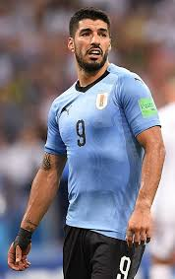
that are professional at practising sports.
REMEMBER ( RECUERDA) :
*Can ( refers to abilities or permission)
* should ( refers to things that are convenient/ necessary to do , not obligations )
* shouldn`t ( refers to things that are not convenient for the person to do )
* must ( refers to obligations)
* may ( refers to things that the person probably do)
Pay attention:
can
shouln`t
must + verb - infinitive ( play, eat, smoke, etc )
should
may

Activity 1: Write some things about a professional sportsperson, like Luis Suàrez or
Deborah Rodrìguez:
(At least ( por lo menos ) two words / phrases in each line )

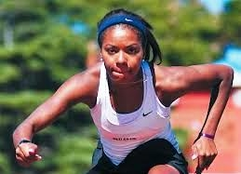
they can: ……………………………………………………………………………….

They should:……………………………………………………………………………

They shouln`t:………………………………………………………………………….

They must : ……………………………………………………………………………..

They may : ………………………………………………………………………………..
Examples: they may become rich people/

*Some ideas to help you: refer to: healthy ( saludables ) activities , unhealthy activities / food / entertainment / probable activities at present or in the future / obligations
___________________________________________________________________________________
Concentrating on extreme sports.
Pay attention to the following explanation:
(me gustarìa/ me atreverìa )
- I would like / dare to do / practise an extreme sport because …………………………… I wouldn`t like/ dare to

- I`m scared of ( tengo miedo de ) risk (riesgo)/ danger / height ( altura) / speed(velocidad).
I`m not scared of (no tengo miedo de) …….
It`s risky ( arriesgado)/ dangerous / fantastic / exciting

example : I wouldn`t dare to practise mountain biking because I`m scared of ……….

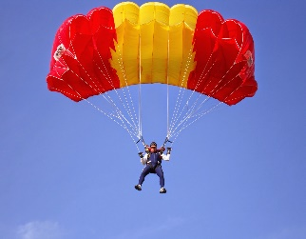
Activity 2.
Complete the blanks using adequate words from the list below or choose the correct option :
risky( arriesgado)/ the air/ dangerous/ danger / water / parachuting ( paracaidismo )/ extreme/ height / equipment / parachute

……………………….is an ………………sport. People practice it in ……………..

You need a ……………….., and a special ……………….. This sport is qualified as …………

and ……………./ I would / wouldn`t like to practise an extreme sport because I`m / I`m not scared of

………..and ………………… People ( may/ should/ must ) ( take precautions/ drink alcohol/ have an
accident ).

(The parts underlined are choices ( las partes subrayadas son opciones para elegir la correcta)

Activity 3. Now, write a small text (about an extreme sport) , similar to the previous one, including ,also, the parts like the ones that are underlined, that you have to choose: ( incluya tambièn, frases similares a las que estàn subrayadas en el texto de actividad 2 )
Text
…………………………………………………………………………………………………………………………..
………………………………………………………………………………………………………………………….
…………………………………………………………………………………………………………………………….
…………………………………………………………………………………………………………………………….
……………………………………………………………………………………………………………………………
……………………………………………………………………………………………………………………………

