A Healthy Lifestyle
Read this article.
Name: | Group:
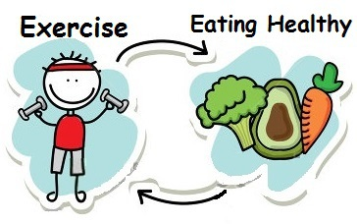
As time goes by, doctors and scientists are finding a strong relationship between the mind and the body. It's becoming clear that how you feel mentally and emotionally is very important for the way you feel physically. Have you ever thought that once you passed the age of 20 you start to die? Of course, that is generally a slow process but you can't escape from it. Teenagers find it difficult – if not impossible- to imagine themselves as middle-aged or old people. That’s because they are young, fit and strong; however, if they don't get into the habit of taking regular exercise early in life to keep like that as long as possible, they will have lots of problems when they are older. One of the easiest ways to keep fit is to stick to a healthy diet, that is to say, to eat fruit, fresh vegetables and food containing fibre, regularly. Smoking is something you must give up if you want to be healthy. Also, try to reduce your alcohol consumption and avoid being too fat.
- Circle T (True) or F (False).
1 There is a relationship between mind & body. T F
2 Our bodies start to die slowly after our twenties. T F
3 Teenagers know how old people feel. T F
4 Exercising early in life is important. T F
5 You will not get any health problems with exercise. T F
6 We should keep a healthy diet. T F
7 Being fat is ok. T F
8 Alcohol is very bad for you. T F

- What about you? Are you a healthy person? Why/why not?
Give examples.

https://en.islcollective.com/download/english-esl-worksheets/vocabulary/health-and-going-doctor/healthy-lifestyle-2/116024

