MUSIC QUIZ

Activity 1 - Listen to six extracts from very popular songs. Write the names of singers or bands under each picture. Order them and write the numbers. Your friends or your family can help you.



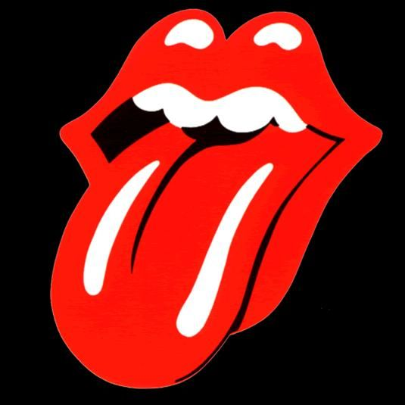
A) .................................. B) ........................................................





C) ............................................... D) .........................................................

E) ................................................... F) .......................................................
Activity 2 – Which band or singer do you like best? Why?

I like ......................................................because ...................................
..........................................................................................................................
Activity 3 – Write (or copy and paste) the lyrics of a song in English that you like. Please, do not translate it, just tell me what it is about, or what the message is (what it means) and why you like it.

