Datos:
Profesora Alicia Velàzquez Inglès
Grupos : 5to C1, 5toc2, 5to C3, 5to B1, 5to B2, 5toB3, 5toB4, 5toB5, 5To B6
Direcciòn de mail para enviar : alivelgam@hotmail.com

Hola, queridos muchachos. Esperando que uds y sus flias se encuentren bien. Seguimos en la página del liceo y me envían las tareas por el mail ya conocido por uds.
Muchos saludos. Espero verlos pronto. Prof. Alicia Velàzquez
------------------------------------------------------------------------------------------------------------
5TH HOMEWORK 17 th APRIL 2020
Student`s name: …………………………………. Group:……………….
Referring to sports/ physical activity

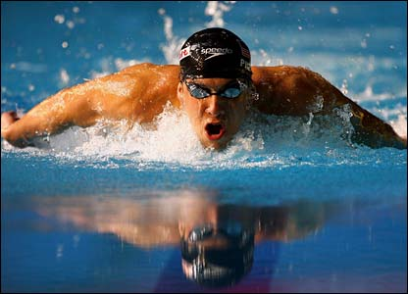
Read the following text and do activity 1.
People start a physical activity in their free time and they feel great, both physically and emotionally . Practising sport gives the person a lot of advantages apart from keeping you fit. When you make this decision, the most important point is that you do good to yourself. The person feels satisfied and this increases also our self-esteem. A sport frequently becomes a passion, and people are happier, continue young and live longer . Another positive point is that you can meet a lot of people and make friends. Also, doing a sport helps you to lose weight and, in most cases, it gives good results. You get a good physical condition and also reduces the risk of many diseases. The heart becomes stronger, the stomach works appropriately, and often people sleep well. As you can see, the advantages for your body are unquestionable.

New words / expressions :
fit: estar en forma / do good: hacerse bien/ Increases: aumenta / become: se transforma / advantage: ventaja / disadvantage: desventaja/ risk of diseases/ riesgo de enfermedades/
heart: corazón / work: funciona ( en este texto)/ lose weight : perder peso

Activity 1. Read the text and pay attention to the expressions in black, underlined (subrayadas)
Now, write the appropriate phrases/ words below( debajo) in the chart :
Benefits that practising a sport gives the person.
( los beneficios del deporte para la persona)
You can repeat the phrases.
1.- for the body :

2.- for the mind ( mente):

3.- for the life:

4.- for our weight( peso) :

Activity 2: Using the information about sports that you have found out ( has averiguado) in Homework 4.
Fill in the lockers with adequate information
At least two words in each line ( por lo menos 2 en cada lìnea)
Type of sports: traditional and extreme
At least two words in each line ( por lo menos 2 en cada lìnea)
a.- Names of traditional sports:……………………………………………………………………………………

b.- Places to practise traditional sports:………………………………………………………………………….

c.- Places to practise extreme sports :……………………………………………………………………………..

d: Adjectives to qualify extreme sports : …………………………………………………………………………..

17th April 2020 Teacher: Alicia Velàzquez

